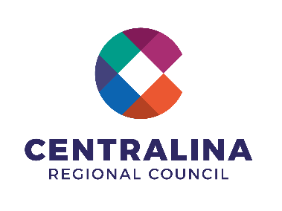 **Pre-Disaster Recovery Planning**

**Recovery Committee Annex Lead/Support Agency Questions and Considerations**

## Day-to-Day Tasks

1. What does your organization do day-to-day that you think may be useful in disaster recovery?
2. Are there any resources, programs, and partners that you rely on for support to carry out the tasks of your day-to-day operations?
   1. Do you foresee these as needs during recovery?
   2. If so, what would you need and who would you request it from?
      1. Do you have a formal mechanism to request this support?
         1. If so, what are they (e.g., MOUs, etc.)?

## Recovery Committee Lead/Support Agency Tasks

1. How has your agency and/or subdivisions of your agency been involved in recovery efforts in past disasters?
   1. If so, when and for how long did you provide support?
2. What do you consider to be the overarching tasks vital to supporting community recovery efforts?
   1. Short-Term (days to weeks following the disaster)?
   2. Long-Term (months to years following)?
3. Does your agency or division have experience supporting administration of any federal Stafford Act programs (e.g., CDBG-DR, SBA, PA, IA, HMGP etc.)?
4. What existing programs address key concerns in this recovery area during blue skies? How could that program be leveraged during recovery?
5. Are there any established collaborations (e.g., roundtables, task forces, etc.) that could help with recovery functions?
6. What expertise or resources does the agency have related to this committee’s focus area?
7. What existing planning has been done related to this committee’s focus area?
8. What supporting partners would you need assistance from to help you complete your tasks/roles?
9. Are there any programs, grants, Authorities/References/State/Federal Programs that support your operations, both during day-to-day operations and/or during recovery?
10. At what point do you consider your role in the recovery effort to be complete?
    1. At what point do you consider the community recovery effort to be complete?
       1. Would you be back to your day-to-day normal operations at that point?

## Other Questions

1. What non-traditional partners do you think should be “brought to the table” during recovery?
2. What is the best way for emergency management to coordinate with you following an emergency?