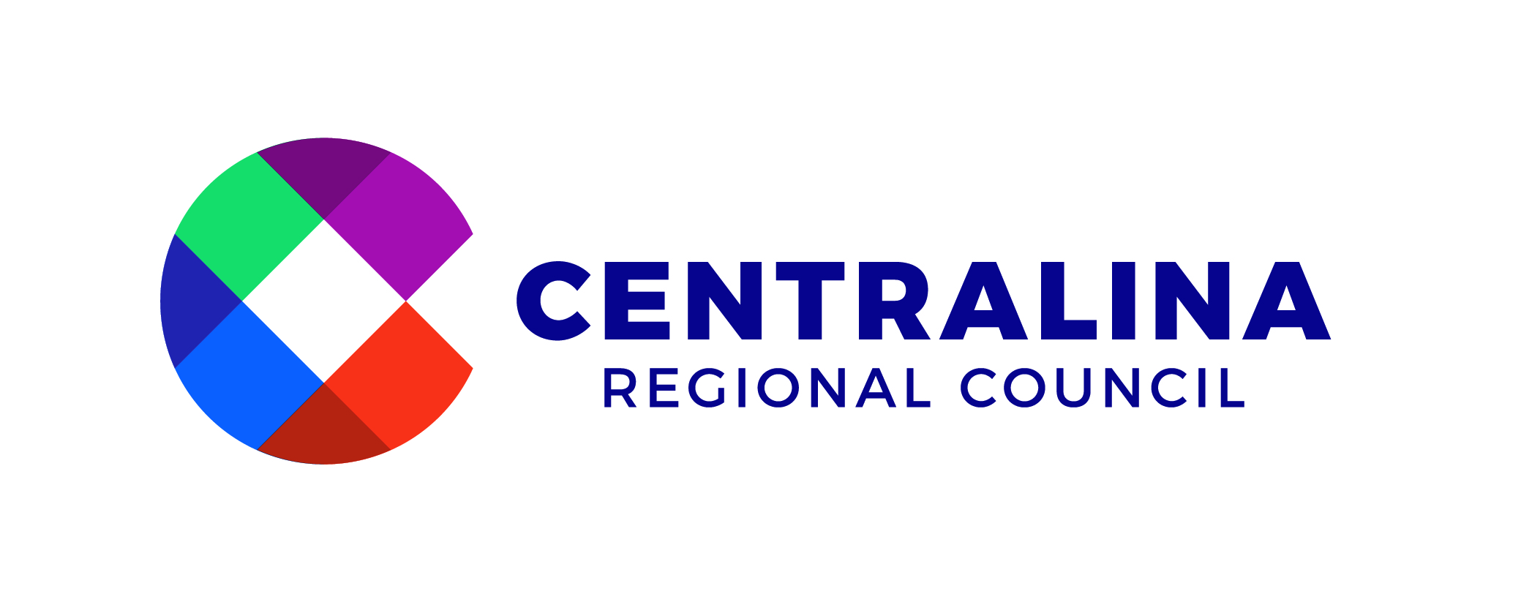

Advancing the Plan Committee Meeting Minutes
March 19, 2023

Jurisdictions/Organization | Committee Members Present | Centralina Staff and Guests Present
City of Kannapolis  City of Charlotte  City of Salisbury  NC Public Transportation  Gaston Business Alliance  Anson County  Gaston County  City of Gastonia  Stanly County  Charlotte Regional Business Alliance  City of Kings Mountain  City of Charlotte  Gaston County  City of Concord  Mecklenburg County  Town of Davidson  Huntersville  NC Department of Transportation  Mecklenburg County  Cabarrus County  City of Charlotte | Darrell Hinnant  Vi Lyles  Karen Alexander  David Rhew  Pat Mumford  Jarvis Woodburn  Bob Hovis  Jennifer Stepp  Andy Lucas  Janet LaBar  Scott Neisler  Marcus Jones  Kim Eagle  Lloyd Payne  Leigh Altman  Rusty Knox  Melinda Bales  Tony Lathrop  Dena Diorio  Mike Downs  Lauren Livingston | Michelle Nance, Centralina  Jason Wager, Centralina  Narissa Claiborne, Centralina  Sarah Niess, Centralina  Geraldine Gardner, Centralina  Luke Lowry, Centralina  Guests  Jason Lawrence, CATS

Call to Order
Co-Chair Mayor Lyles, City of Charlotte, called the meeting to order.
Co-Chair Mayor Hinnant, City of Kannapolis, proceeded with a roll call of all meeting attendees.

Welcome, and Why this Committee is Important:
Mayor Lyles shared the group’s meeting objectives including.
- Connect Beyond project updates
- Reviewing and discussing the peer model case study in small groups
- Discussing local and regional legislative priorities
- Lastly, Review the project’s communication needs.

Agenda Items:

- Approval of January 27, 2023, meeting minutes
Commissioner Hovis called for a motion to approve the meeting minutes.
Seconded by: Andy Lucas
The motion passed unanimously.

- Agenda Item #2: Ideas in Action - Latest Project Updates
Mayor Hinnant introduced Michelle Nance, Senior Director, Centralina Regional Council. Michelle reviewed recent CONNECT Beyond project successes and then reviewed several current CONNECT Beyond implementation projects, including (1) developing a regional transportation demand management (TDM) plan and the (2) Seamless CONNECTions project activities. Michelle highlighted potential TDM strategies that could be pursued in a regional TDM plan that can help mitigate the impacts of single-vehicle occupancy. She forecasted that the Committee would have an opportunity to give input for the development of the regional TDM plan at an upcoming meeting. For Seamless CONNECTions, Michelle reviewed phase one activities including identifying near-term opportunities for transit coordination across the region, convening of a Service Planning Working Group, and continuing discussions around formalizing transfers and technology/data sharing between transit agencies.
- Case Study: CVTA (Central Virginia Transportation Authority)
Geraldine Gardner, Executive Director, Centralina Regional Council, reviewed some background information on the Central Virginia Transportation Authority (CVTA), a regional transportation agency for the Richmond, VA region. Geraldine shared information about the CVTA’s governance structure, funding sources/distribution and project selection process. Jason Wager, Assistant Planning Director, Centralina Regional Council, introduced an engagement activity for the Committee to discuss in small groups. Project staff joined group discussions to take notes.

- Legislative Education and Advocacy

Geraldine reviewed Centralina’s legislative asks to support CONNECT Beyond project implementation – this funding would support Centralina’s efforts related to developing a regional transportation demand management program, aiding for rural mobility hubs, micro-transit/right sizing of transit systems, and regional governance exploration.

Chris Wall, from EQV Strategic, joined the meeting virtually to discuss the current legislative session and the opportunities and challenges for a regional project like CONNECT Beyond. Committee members had time to ask Chris questions following his presentation.

- Communication Strategy Development: Committee Homework Survey

Geraldine reviewed the homework survey that Committee members participated in on project communication needs and messaging for specific audiences. Top survey responses for messaging for state lawmakers, local elected officials, and the public were reviewed. Geraldine then led the group to a discussion of communication tools that project staff could provide to support Committee members.

Closing Comments
Mayor Lyles asked the members for some closing comments and then adjourned the meeting.

